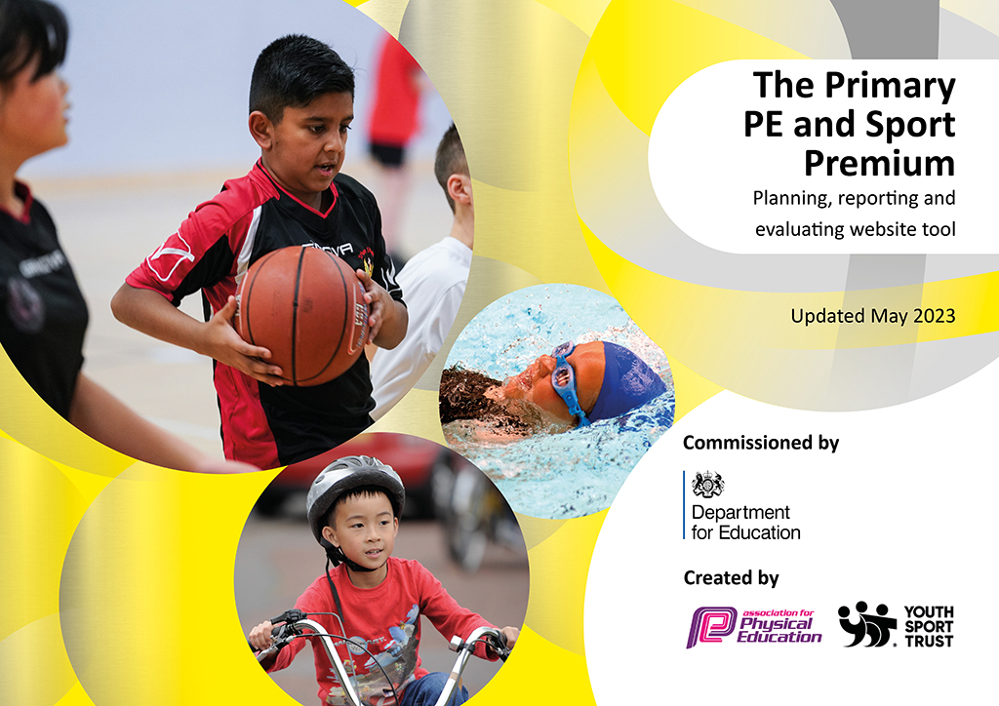
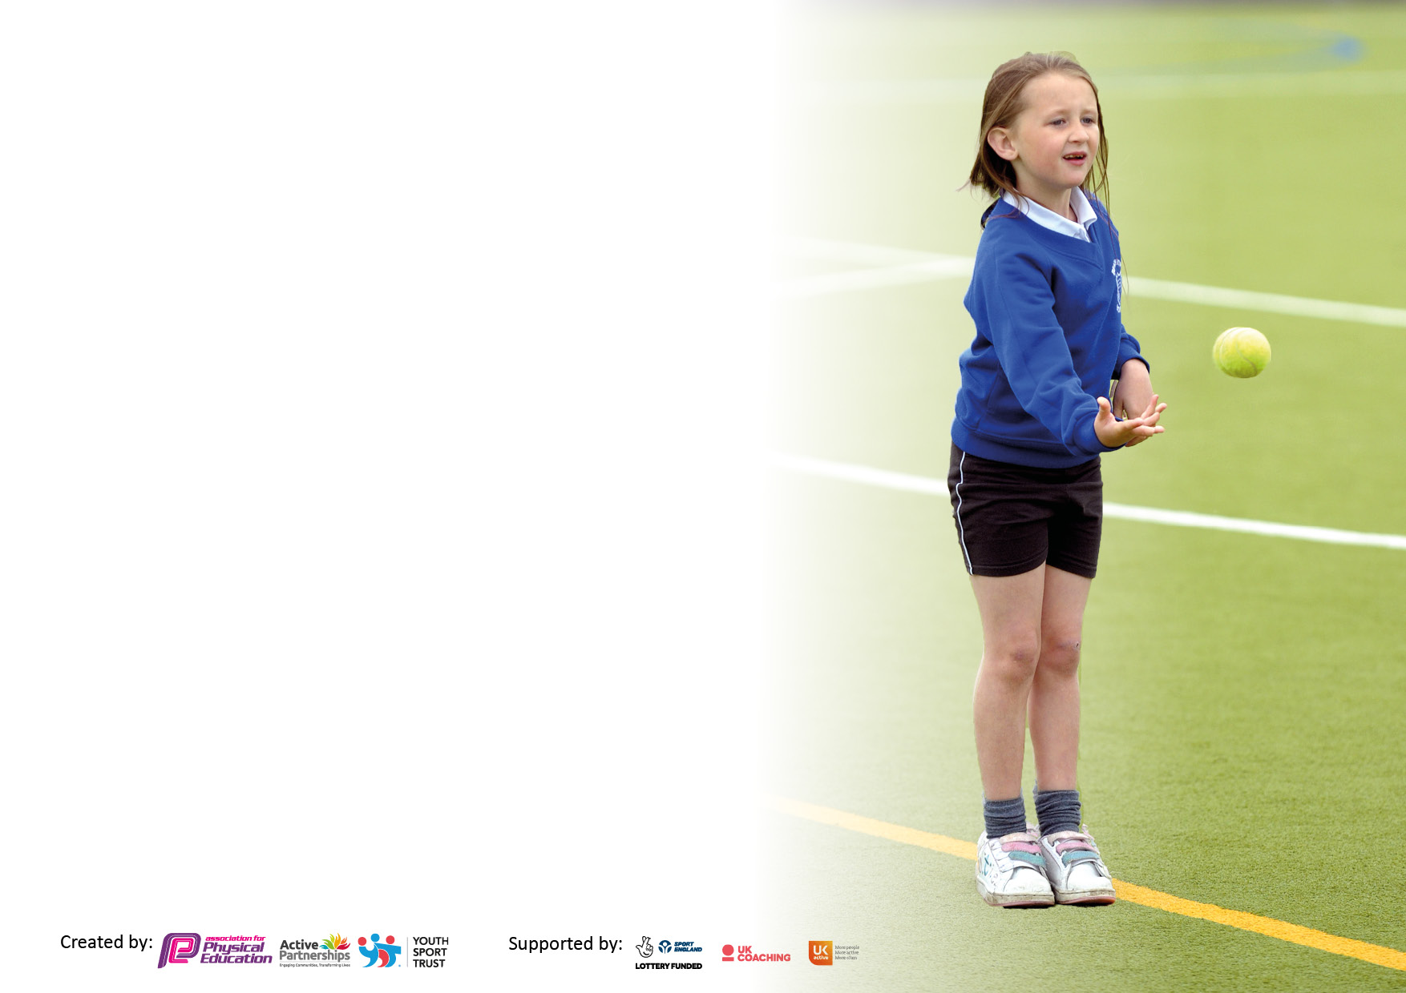

It is important that your grant is used effectively and based on school need. The Education Inspection Framework makes clear there will be a focus on ‘whether leaders and those responsible for governors all understand their respective roles and perform these in a way that enhances the effectiveness of the school’.

Under the Quality of Education Ofsted inspectors consider:
Intent - Curriculum design, coverage and appropriateness
Implementation - Curriculum delivery, Teaching (pedagogy) and Assessment
Impact - Attainment and progress

To assist schools with common transferable language this template has been developed to utilise the same three headings which should make your plans easily transferable between working documents.

Schools must use the funding to make additional and sustainable improvements to the quality of Physical Education, School Sport and Physical Activity (PESSPA) they offer. This means that you should use the Primary PE and sport premium to:

- Develop or add to the PESSPA activities that your school already offer
- Build capacity and capability within the school to ensure that improvements made now will benefit pupils joining the school in future years
- The Primary PE and sport premium should not be used to fund capital spend projects; the school’s budget should fund these.

Pleasevisitgov.ukfortherevisedDfEguidanceincludingthe5keyindicatorsacrosswhichschoolsshoulddemonstrate animprovement.Thisdocumentwillhelpyoutoreviewyourprovisionandtoreportyourspend.DfEencouragesschools to use this template as an effective way of meeting the reporting requirements of the Primary PE and Sport Premium.

We recommend you start by reflecting on the impact of current provision and reviewing the previous spend.

Schools are required to publish details of how they spend this funding, including any under-spend from 2021/2022, as well as on the impact it has on pupils’ PE and sport participation and attainment. All funding must be spent by 31st July 2023.

We recommend regularly updating the table and publishing it on your website throughout the year. This evidences your ongoing self-evaluation of how you are using the funding to secure maximum, sustainable impact. Final copy must be posted on your website by the end of the academic year and no later than the 31st July 2023. To see an example of how to complete the table please click HERE.
Created by: Supported by:

Details with regard to funding
Please complete the table below.

Total amount carried over from 2021/22 | £5,934
Total amount allocated for 2021/22 | £18,430
How much (if any) do you intend to carry over from this total fund into 2022/23? | None
Total amount allocated for 2022/23 | £18,430
Total amount of funding for 2023/23. To be spent and reported on by 31st July 2023. | £24,364
Swimming Data
Please report on your Swimming Data below.

Meeting national curriculum requirements for swimming and water safety.

N.B. Complete this section to your best ability. For example you might have practised safe self-rescue techniques on dry land which you can then transfer to the pool when school swimming restarts.
Due to exceptional circumstances priority should be given to ensuring that pupils can perform safe self rescue even if they do not fully meet the first two requirements of the NC programme of study
What percentage of your current Year 6 cohort swim competently, confidently and proficiently over a distance of at least 25 metres?  N.B. Even though your pupils may swim in another year please report on their attainment on leaving primary school at the end of the summer term 2022.  Please see note above | 97%
What percentage of your current Year 6 cohort use a range of strokes effectively [for example, front crawl, backstroke and breaststroke]?  Please see note above | 97%
What percentage of your current Year 6 cohort perform safe self-rescue in different water-based situations? | 97%
Schools can choose to use the Primary PE and sport premium to provide additional provision for swimming but this must be for activity over and above the national curriculum requirements. Have you used it in this way? | Yes/No

Action Plan and Budget Tracking
Capture your intended annual spend against the 5 key indicators. Clarify the success criteria and evidence of impact that you intend to measure to evaluate for pupils today and for the future.

Academic Year: 2022/23 | Total fund allocated: £24,634 | Date Updated: July 2023
Key indicator 1: The engagement of all pupils in regular physical activity – Chief Medical Officers guidelines recommend that primary school pupils undertake at least 30 minutes of physical activity a day in school |  |  |  | Percentage of total allocation:
 |  |  |  | 36%
Intent | Implementation |  | Impact
Your school focus should be clear what you want the pupils to know and be able to do and about  what they need to learn and to  consolidate through practice: | Make sure your actions to achieve are linked to your intentions: | Funding allocated: | Evidence of impact: what do pupils now know and what can they now do? What has changed? | Sustainability and suggested next steps:
RS Coaching delivers high impact physical activity during PE lessons. Children are encouraged to take leadership or volunteer roles that support physical activity within school every day. | RS Coaching delivers PE lessons across Key Stage 1 and 2 (supported by the teacher). Leads meetings with the Mini-Leaders to develop lunch-time active play. | £8765 | High quality PE lessons, increasing staff knowledge and confidence in specific areas of PE. KS2 children undertake leadership or volunteer roles that support social and physical activity within school every day. | Use RS Coaching as a CPD tool for staff as they support and observe their lessons. Use of IPads to record good practice.
Key indicator 2: The profile of PESSPA being raised across the school as a tool for whole school improvement |  |  |  | Percentage of total allocation:
 |  |  |  | 8%
Intent | Implementation |  | Impact
Your school focus should be clear what you want the pupils to know and be able to do and  what they need to learn and to  consolidate through practice: | Make sure your actions to achieve are linked to your intentions: | Funding allocated: | Evidence of impact: what do pupils now know and what can they now do? What has changed? | Sustainability and suggested next steps:
Experience Days  (whole school Tough Rower)  Hire of Greys Rec  SEND resources and equipment box  Positive Experiences at break and lunchtime through positive play  Midday Supervisor Training  EYFS Balanceability | To increase the range of sport experiences across the key stages.  Use of grassed area for KS1 and 2 Sports Day and ASC for KS2.  To support SEND pupils during PE lessons and ASC.  To support KS2 children to make better choices and interact more coherently during break and lunchtimes to create a culture of respect, conflict resolution and positive mind-sets.  To support midday supervisors, manage and engage pupils at lunchtime introducing games, utilising existing space and equipment.  To support pupils with riding a bike at their appropriate level; to gain confidence and independence when riding a bike; increase their spatial awareness when riding a bike; understand how to stay safe whilst riding a bike. | £475  £265  £239  £250  £150  £651 | Pupils have the opportunities to engage in new sports. Increased confidence and engagement in a range of sports.  Pupils have access to grassed areas to participate in a range of sporting activities.  SEND pupils can achieve personal goals in all aspects of PE.  KS2 children are engaged in active, positive play daily.  Increased confidence of staff to lead games and direct Mini- Leaders.  Increased number of pupils riding a bike without stabilisers. | Children are experiencing a wealth of activities within school during break and lunchtimes and in their PE lessons.  Adults are engaging the children in positive play.

Key indicator 3: Increased confidence, knowledge and skills of all staff in teaching PE and sport |  |  |  | Percentage of total allocation:
 |  |  |  | 4%
Intent | Implementation |  | Impact
Your school focus should be clear | Make sure your actions to | Funding | Evidence of impact: what do | Sustainability and suggested
what you want the pupils to know | achieve are linked to your | allocated: | pupils now know and what | next steps:
and be able to do and about | intentions: |  | can they now do? What has
what they need to learn and to |  |  | changed?
consolidate through practice:
PE Lead gains Level 5 Certificate In Primary School Physical Education Specialism | To upskill PE Lead to improve the overall delivery of the physical education curriculum within school. | £975 | Raising standards of physical education teaching and learning in school. | PE Lead can deliver CPD to staff and cluster schools.
Key indicator 4: Broader experience of a range of sports and activities offered to all pupils |  |  |  | Percentage of total allocation:
 |  |  |  | 46%
Intent | Implementation |  | Impact
Your school focus should be clear | Make sure your actions to | Funding | Evidence of impact: what do | Sustainability and suggested
what you want the pupils to know | achieve are linked to your | allocated: | pupils now know and what | next steps:
and be able to do and about | intentions: |  | can they now do? What has
what they need to learn and to |  |  | changed?
consolidate through practice:
Appropriate equipment to enhance PE lessons across the Key Stages. Specialist equipment to support training for competitions.  Improve KS1 and KS2 playground provision.  Improve KS2 sports kit when participating in intra and inter sporting events. | Complete an audit of resources within PE store; liaise with sport specialist about equipment needed for specialist lessons this academic year.  PE lessons are at least good across the school, equipment and resources used effectively to enhance all areas of PE.  Complete a pupil voice to gauge what pupils want to play with during break and lunchtimes.  Purchase a lightweight, breathable sports kit for KS2 pupils. Liaise with KS2 pupils about what they would like to wear and discuss how it would improve their well-being and performance during competitions. | £215  £10,745  £315 | Children show greater confidence using the equipment thus equipping them with the skills to succeed in a range of lessons and competitive events.  Children have equipment to use during break and lunchtimes to improve their gross and fine motor skills. Children play collaboratively and positively.  Children have a specific sports kit to wear when participating in intra and inter sporting events. | Monitoring of pupils in lessons, annotations/notes made on PE AfL grids.

Key indicator 5: Increased participation in competitive sport |  |  |  | Percentage of total allocation:
 |  |  |  | 6%
Intent | Implementation |  | Impact
Your school focus should be clear | Make sure your actions to | Funding | Evidence of impact: what do | Sustainability and suggested
what you want the pupils to know | achieve are linked to your | allocated: | pupils now know and what | next steps:
and be able to do and about | intentions: |  | can they now do? What has
what they need to learn and to |  |  | changed?
consolidate through practice:
AVSSP affiliation working in partnership with school allowing Key Stage 1 and 2 pupils attend a range of competitive sporting events.  RS Coaching working in partnership with cluster schools to improve the provision for PP pupils/pupils working towards objectives in PE.  Attend DCFC Soccerstars event to increase KS1 participation inter-school events.  Attend the British Dodgeball KS2 tournament. | Pupils have the opportunity to participate in inter and intra-school sporting events.  All pupils have access to a range of competitive sports tailored to their ability.  Younger pupils are given the opportunity to broaden their experiences in sport.  KS2 (GDS) pupils attend a regional event to compete against other schools | £1100  £50  ??  £50 | All pupils have access to a range of competitions whatever their age or ability. Pupils will continue to develop a sense of team spirit and personal pride in their school and their achievements. | Children’s attendance will be recorded on the tracker to monitor gaps in cohorts.  Dialogue with pupils about competitions they would enjoy participating in, cross referencing with AVSSP competition booklet.

Signed off by
Head Teacher: | Helen Britten
Date: | July 2023
Subject Leader: | Jo Reed
Date: | July 2023
Governor: | Liz Sheppard
Date: | July 2023

